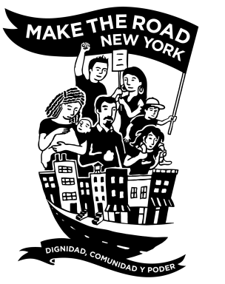
MAKE THE ROAD - NY, NJ, CT, PA
EXECUTIVE ORDERS
DONALD TRUMP
1.25.17
In his first immigration actions after taking power last week, Trump signed two executive actions: (1) continue militarizing the border and (2) expanding the machine to deport people within the United States.
Executive Order # 1 - Militarize the Border
Directs the federal government to:
- Expand the wall on the Mexican border.
- Create more detention centers near the border with Mexico to facilitate the deportation of more people.
- Detain more people who are fighting their deportation cases instead of letting them fight from outside detention.
- Hire 5,000 more Border Patrol agents.
- Expand "expedited removal," which is a way to deport people without seeing an immigration judge.
- Declare that immigration has access to all federal lands - our assumption is that Trump is referring to Native American reservations within the U.S.
- Bring federal criminal charges against more people for crossing the border.

Executive Order # 2 - Deportations within the Country
Directs the federal government to:
- Prioritize the deportation of any person who may be deported under the law (which includes all undocumented people) who also has one of the following:
  - Has committed acts that may be a crime,
  - Has committed fraud against the government (including fraud related to public benefits), or
  - Already has a deportation order.
- Make a determination on within one-year about civil fines and penalties you can collect related to immigration.
- Hire 10,000 more ICE agents.
- Expand program 287(g) where local police sign contracts with immigration to act as immigration agents.
- Bring back the "Secure Communities" program (also known as insecure communities) that links local precincts with ICE to share information about who was arrested.
- Seek ways to remove federal money from "Sanctuary Cities," cities like NYC and others that have decided not to cooperate with ICE to help them deport people.
- Bring federal criminal charges against more people for criminal offenses related to immigration.
- Penalize countries that refuse to accept people deported from the U.S.

What does it mean for us?
Trump is demonstrating that he will live up to his campaign promises - and these actions are serious attacks on our community. He's trying to scare and divide us. It is time to mobilize and defend our families and communities.
It is important to understand that the southern border is already heavily militarized. Presidents George W. Bush and Barack Obama already secured a lot of funding to build the wall, hire more border patrol agents, and increase surveillance. This militarization was destructive to the environment and forced migrants to enter the most dangerous areas of the border, where many have lost their lives. Also, President Obama has already built a large deportation machine inside the country. Trump wants to continue that militarization, detain more people without giving them the opportunity to fight their deportation cases from outside detention, and deport more people more quickly. But to do all that, he'll need money from Congress.
Resist!
Now is the time to resist and defend our families, neighbors, and everything we have gained. We are forming "Defense Committees" - and each of us must connect to the network so we can respond quickly and know all our rights if raids and similar actions begin.

